
Anjuman-I-Islam’s
M. H. SABOO SIDDIK COLLEGE OF ENGINEERING
8, Saboo Saddik Polytechnic Road, Byculla, Mumbai, Maharashtra 400008
DEPARTMENT OF INFORMATION TECHNOLOGY

ITP701 MAJOR PROJECT - 1

Title of the Project

Blood Banking Via Cloud Computing

Supervisor/Guide

ER SWATI GURAV

REV - 2019 ‘C’ Scheme

University of Mumbai

Academic Year (2026 -27)

CERTIFICATE

This is to certify that the project entitled “Blood Bank Via Cloud Computing” by "Yamin Khan" (242464), " Mohammed Rumaan Shaikh" (242469), "Abdurrahman Qureshi " (242466), "Abdul Sameer Shaikh" (242471) ” submitted to the University of Mumbai in partial fulfilment of the requirement for the ITP701 Major Project - 1 for the 7TH Semester in Department of Information Technology.

(ER.SWATI GURAV) ER. SHRINIDHI GINDHI
SUPERVISOR/GUIDE MAJOR PROJECT CO-ORDINATOR

( Dr. Zainab Mirza) HEAD OF DEPARTMENT

MINI PROJECT REPORT APPROVAL

This project report entitled " Blood Bank Via Cloud Computing " by "Yamin Khan" (242464), "Mohammed Rumaan Shaikh" (242469), "Abdurrahman Qureshi " (242466), "Abdul Sameer Shaikh" (242471) is approved for the ITP701 Major Project 1 for project of the 7th Semester.

EXAMINER 1

EXAMINER 2

Date :
Place : Mumbai

ACKNOWLEDGEMENT

We would take this humble opportunity to express our sincere gratitude to our project guide ER. Swati Gurav for her valuable advice and direction under

Which the project was executed and to all respected people who provided their kind support and encouragement throughout the project. The success of this project to the most extent rests on every bit of suggestions, advice, and help which they provided us from time to time and also being open and constructive to all the problems that we faced during the entire development lifecycle of our project.

We would also like to extend a big vote of thanks to the coordinator, our teachers, for their constant support and encouragement

YAMIN KHAN (242464)

ABDURRAHMAN QURESHI (242466)

MOHAMMED RUMAAN SHAIKH (242469)

ABDUL SAMEER SHAIKH (242471)
ABSTRACT
The Blood Banking Via Cloud Computing project is designed to provide a centralized, efficient, and easily accessible platform for managing blood-bank activities using cloud computing technology. Traditional blood-bank systems often depend on manual records or isolated databases, which can make it difficult to obtain updated information about donors, blood groups, blood availability, and blood requests.
The proposed system provides a digital platform where donors, hospitals/recipients, and administrators can interact with the blood-bank system. Donors can register and maintain their information, while authorized users can check blood availability and submit blood requests. The administrator can manage donor records, blood-stock information, requests, and other system activities.
Cloud computing provides centralized data storage, accessibility, scalability, and easier management of the system. The project aims to reduce manual work, improve data accessibility, minimize record-management errors, and provide faster access to blood-related information. The system can also be extended in the future with features such as notifications, location-based blood-bank searching, analytics, and emergency blood requests.

TABLE OF CONTENT

Sr.No | Content | Page No
1 | Introduction | 1
2 | Methodology | 3
3 | Design /Implementation | 5
4 | Testing/result and analysis | 8
5 | Timeline Chart | 16
6 | Conclusion | 17
7 | Future Scope | 18
8 | References | 20

INTRODUCTION

Blood is one of the most important resources required during medical emergencies, surgeries, accidents, and treatment of various diseases. Blood banks are responsible for collecting, storing, managing, and distributing blood according to the requirements of patients and healthcare organizations.
In a conventional blood-bank system, information about donors, blood groups, stock, and requests may be maintained through paperwork or separate computer systems. Such approaches can result in data duplication, difficulty in updating records, delayed information retrieval, and limited accessibility.
Cloud computing provides an effective solution to these problems by allowing application data and services to be hosted on centralized cloud infrastructure. Authorized users can access the system through the internet without depending on a particular physical computer.
The proposed Blood Banking Via Cloud Computing system aims to create a centralized platform for managing important blood-bank operations. The system can maintain information about:
- Blood donors
- Blood groups
- Available blood units
- Blood collection and storage
- Blood requests
- Hospitals/recipients
- User accounts
- Administrative activities
The administrator acts as the main controller of the system and can verify and manage information. Donors and authorized users can access relevant services through the application.

Objectives
The major objectives of the project are:
- To develop a centralized cloud-based blood-bank management system.
- To maintain donor information digitally.
- To maintain and update blood-stock information.
- To allow users to check blood availability.
- To provide a facility for submitting blood requests.
- To reduce dependency on manual record keeping.
- To improve the accessibility and management of blood-bank information.
- To provide secure authentication and controlled access.
- To reduce errors and duplication in blood-bank records.
- To provide a scalable platform that can be enhanced in the future.

METHODOLOGY
The project follows a systematic development methodology consisting of requirement analysis, research, system design, technology planning, implementation, testing, and evaluation.

Step 1: Requirement Analysis
The requirements of different users are identified.
Donor requirements:
- Registration and login
- Profile management
- Blood-group information
- Donation-related information
Recipient/Hospital requirements:
- Login
- Search/check blood availability
- Submit blood requests
- Track request status
Administrator requirements:
- Manage donors
- Manage blood inventory
- Manage requests
- Manage users
- Update system information

Step 2: Literature Review
Existing blood-bank management systems and cloud-based healthcare applications are studied. Their features, advantages, and limitations are analyzed to identify possible improvements.

Step 3: Research Gap Identification
The limitations of existing systems are identified, such as:
- Manual record maintenance
- Limited accessibility
- Delayed stock updates
- Difficulty in maintaining centralized information
- Lack of scalable infrastructure

Step 4: System Design
The overall system architecture, database structure, user roles, data flow, and application workflow are designed.

Step 5: Technology Planning
A suitable technology stack is selected based on project requirements. A possible implementation can use:

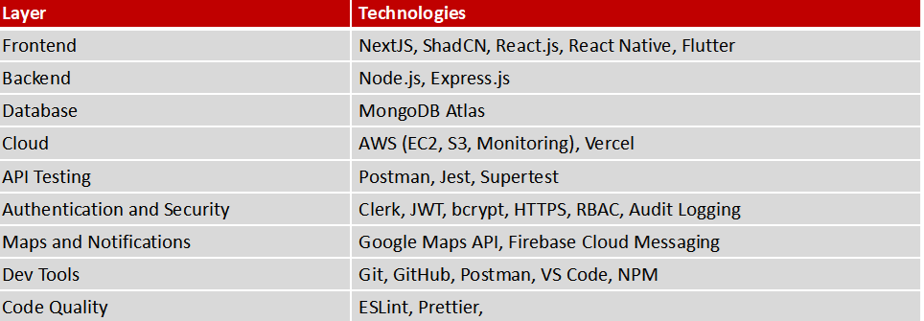

Step 6: Implementation
The application is developed module by module:
- User authentication
- Donor registration
- Donor profile
- Blood inventory
- Blood search
- Blood request
- Administrator dashboard
- Database integration

Step 7: Testing
Individual modules are tested first, followed by integration testing and complete system testing.

Step 8: Deployment and Evaluation
After successful testing, the application can be deployed on cloud infrastructure. Its performance, usability, reliability, and functionality are evaluated.

IMPLEMENTATION AND DESIGN

System Architecture

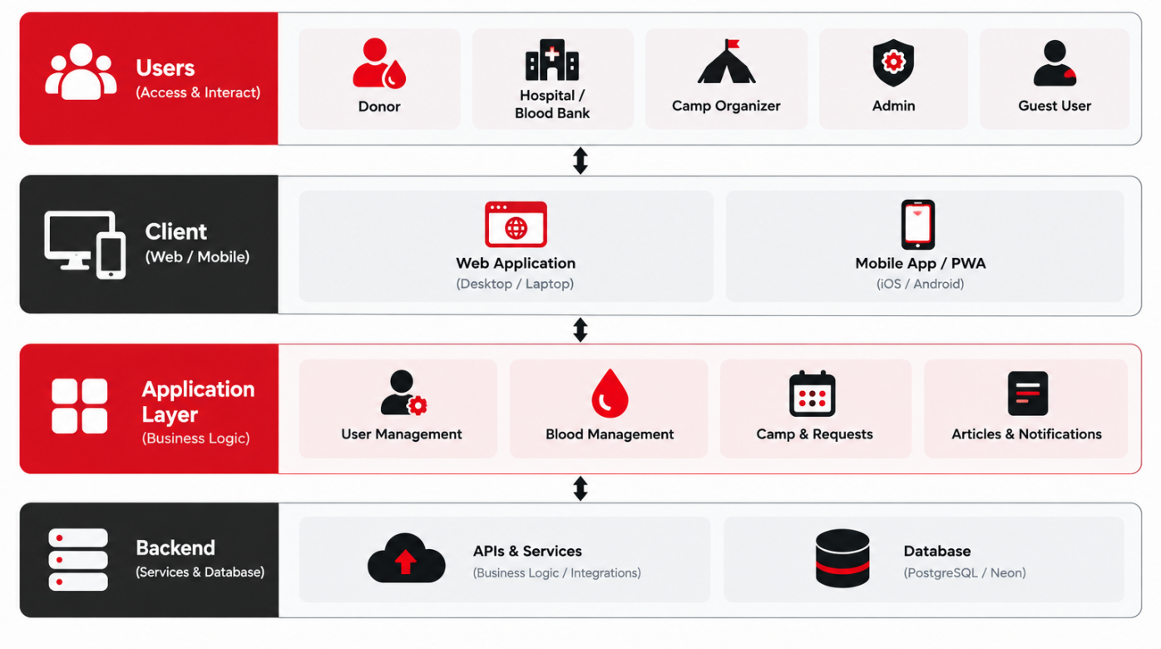

Working of the Architecture

Users access the blood-bank application through the web interface.

The presentation layer accepts user input.

Requests are sent to the application/backend layer.

The application layer validates the request and performs the required operation.

Relevant information is retrieved from or stored in the cloud database.

The result is sent back to the user interface.

Cloud infrastructure provides centralized storage, availability, scalability, and backup facilities.

System Modules

1 User Authentication Module
This module provides:
- User registration
- Login
- Logout
- Password validation
- Role-based access
- Authentication of authorized users

2 Donor Management Module
The donor module maintains:
- Donor name
- Contact details
- Blood group
- Age and basic information
- Donation history
- Donor availability/status

3 Blood Inventory Module
This module manages:
- Blood groups
- Available blood units
- Stock addition
- Stock reduction
- Blood availability
- Inventory updates

4 Blood Request Module
Users or hospitals can:
- Search for required blood
- Submit blood requests
- Specify blood group and quantity
- View request status
- Receive information about request processing

5 Administrator Module
The administrator can:
- Manage users
- Verify donor information
- Manage blood stock
- Manage requests
- Update records
- Monitor system activities

Flowchart : (Overall)

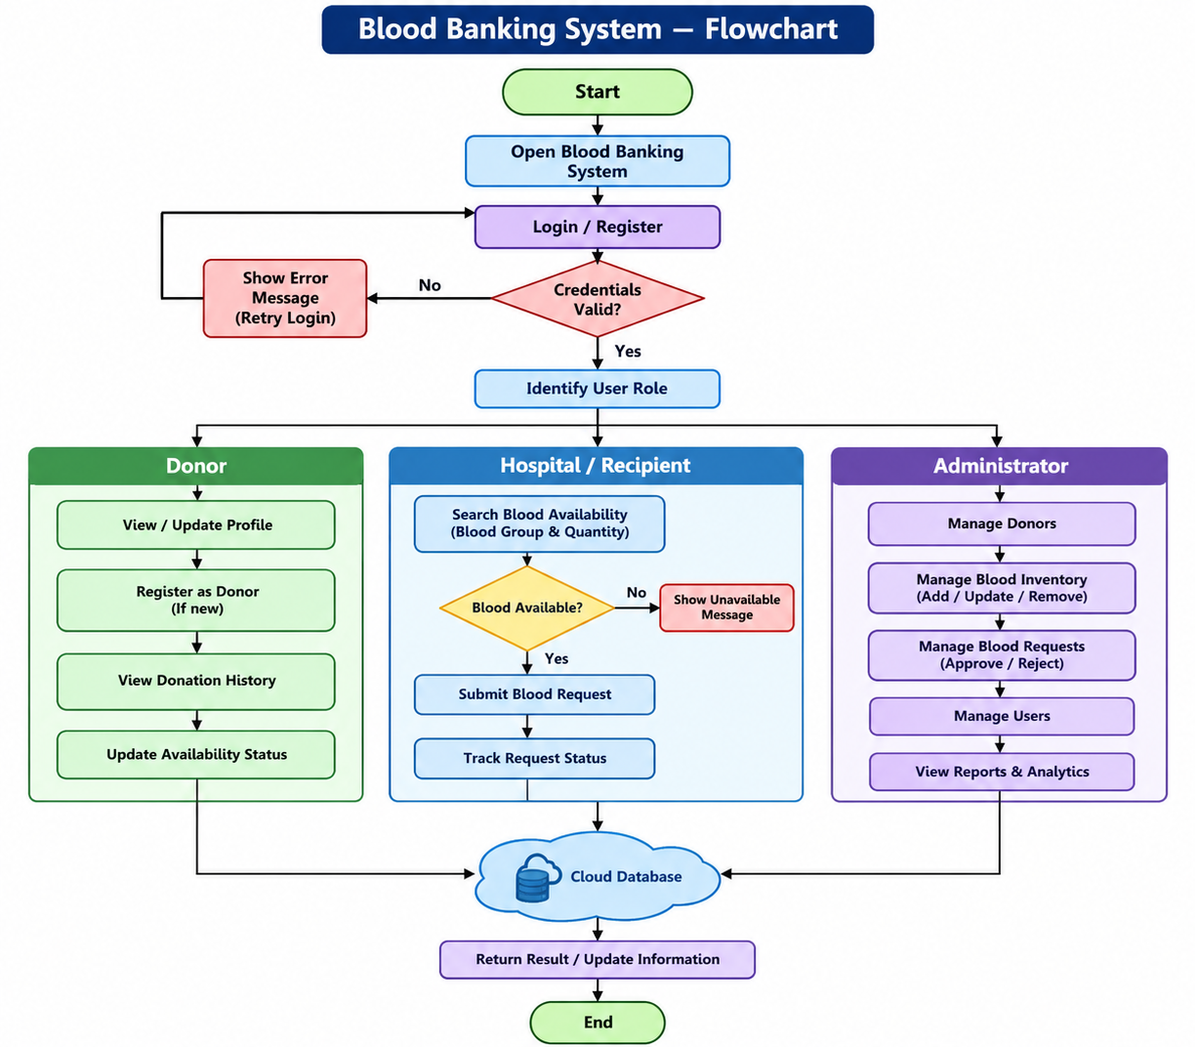

TESTING /RESULT & ANAYLIS

Testing is performed to verify that each component of the Blood Banking Via Cloud Computing system works correctly and that different modules can communicate properly.

Types of Testing
1. Unit Testing
Individual modules such as login, registration, donor management, and blood inventory are tested independently.
2. Integration Testing
Different modules are tested together to ensure that data is transferred correctly between the frontend, backend, and database.
3. Functional Testing
The main functions of the system are tested according to the defined requirements.
4. Validation Testing
User inputs such as email, password, blood group, quantity, and required fields are validated.
5. Authentication Testing
Login credentials and access permissions are tested to ensure that unauthorized users cannot access restricted features.
6. Database Testing
Data insertion, retrieval, modification, and deletion operations are tested.
7. User Interface Testing
The interface is checked for proper navigation, readability, responsiveness, and ease of use.
Test Cases:

Test Case | Test Scenario | Expected Result | Result
TC01 | User registration with valid data | Account should be created | Pass
TC02 | Registration with missing fields | Validation message should appear | Pass
TC03 | Login with valid credentials | User should be logged in | Pass
TC04 | Login with incorrect password | Access should be denied | Pass
TC05 | Donor enters valid information | Donor record should be stored | Pass
TC06 | Search for available blood group | Available stock should be displayed | Pass
TC07 | Search unavailable blood group | System should show unavailable status | Pass
TC08 | Submit valid blood request | Request should be recorded | Pass
TC09 | Admin updates blood stock | Updated stock should be displayed | Pass
TC10 | Unauthorized user opens admin page | Access should be restricted | Pass
TC11 | Logout | User session should end | Pass
TC12 | Retrieve stored records | Correct records should be displayed | Pass

Result: Output Images


Fig.1
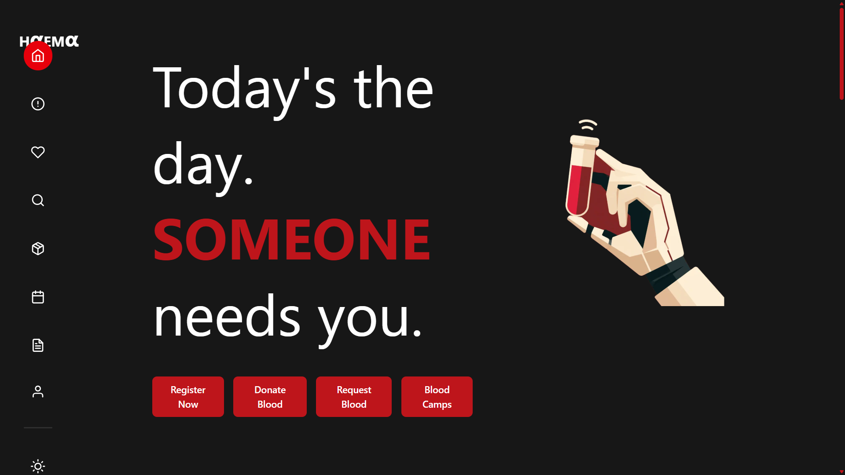

Fig.2

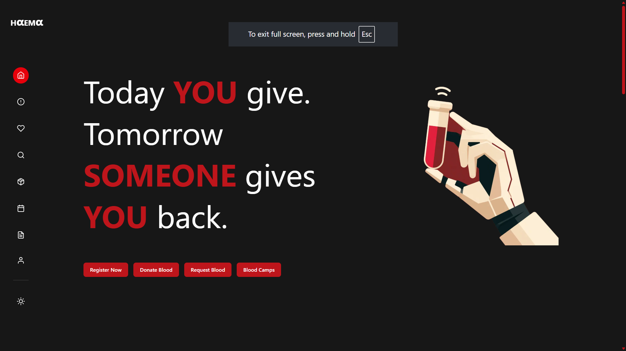

Fig.3

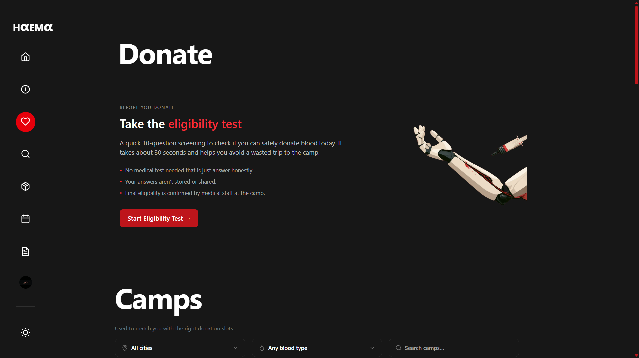

Fig.4

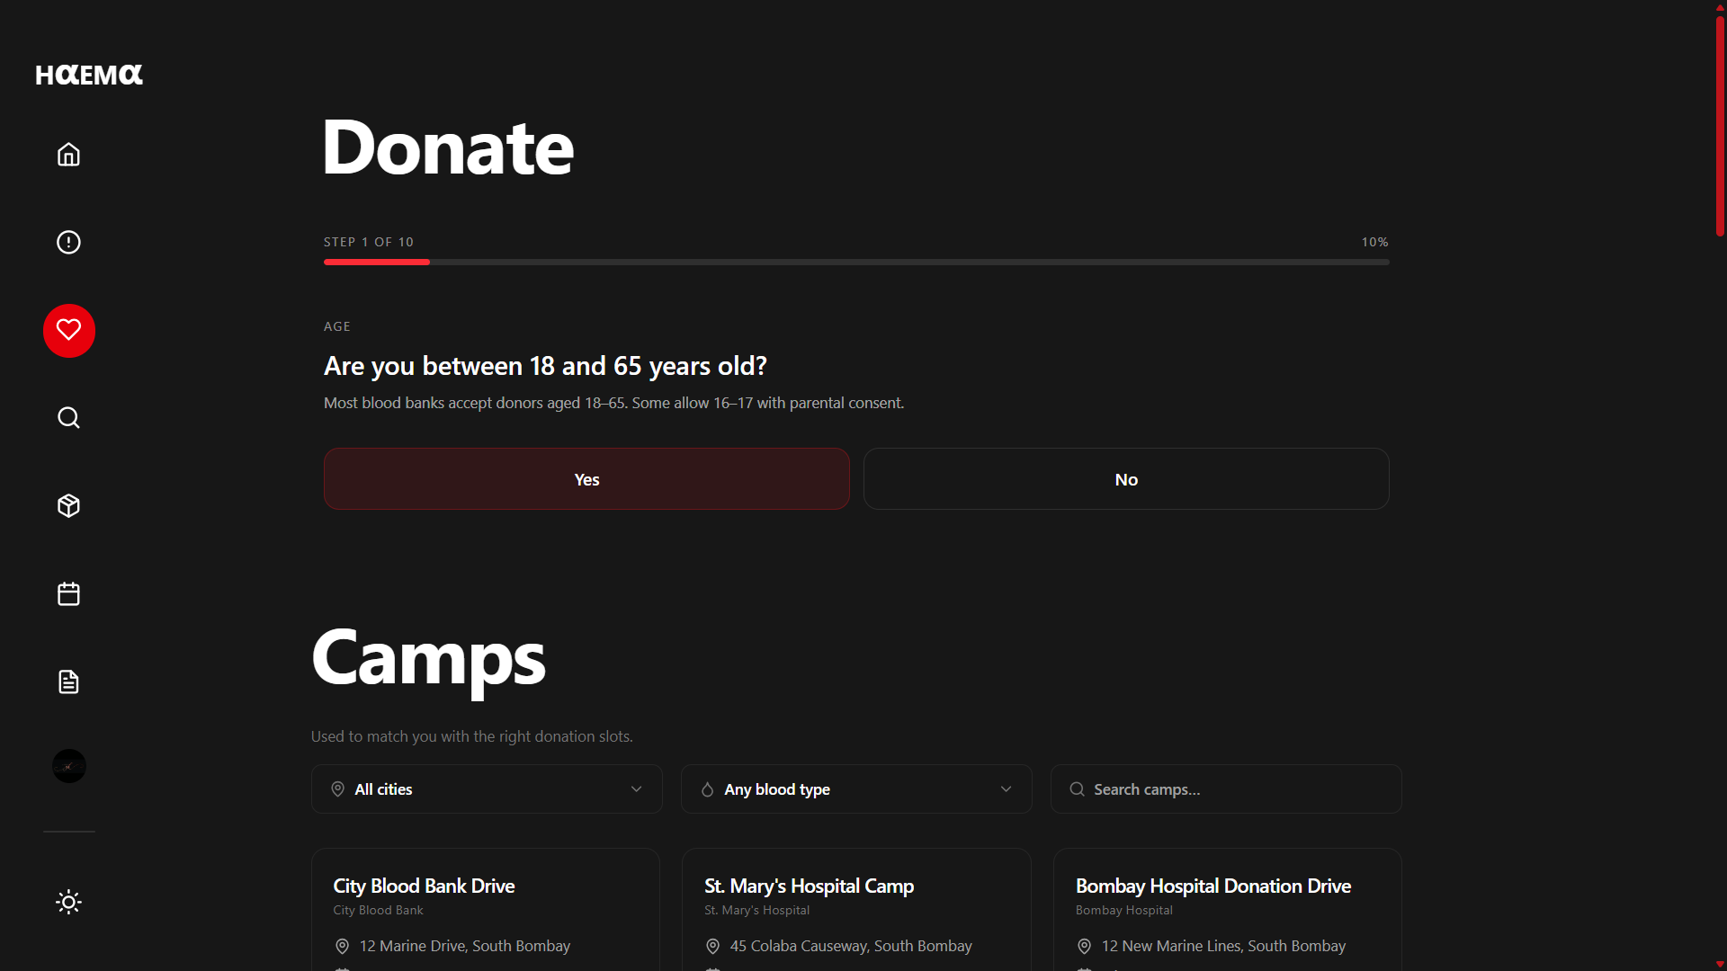

Fig.5

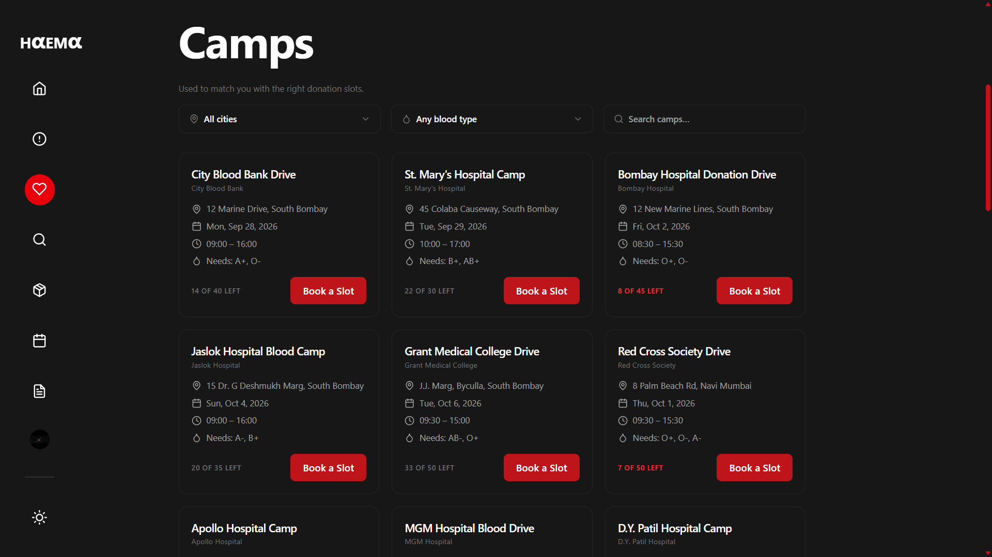

Fig.6

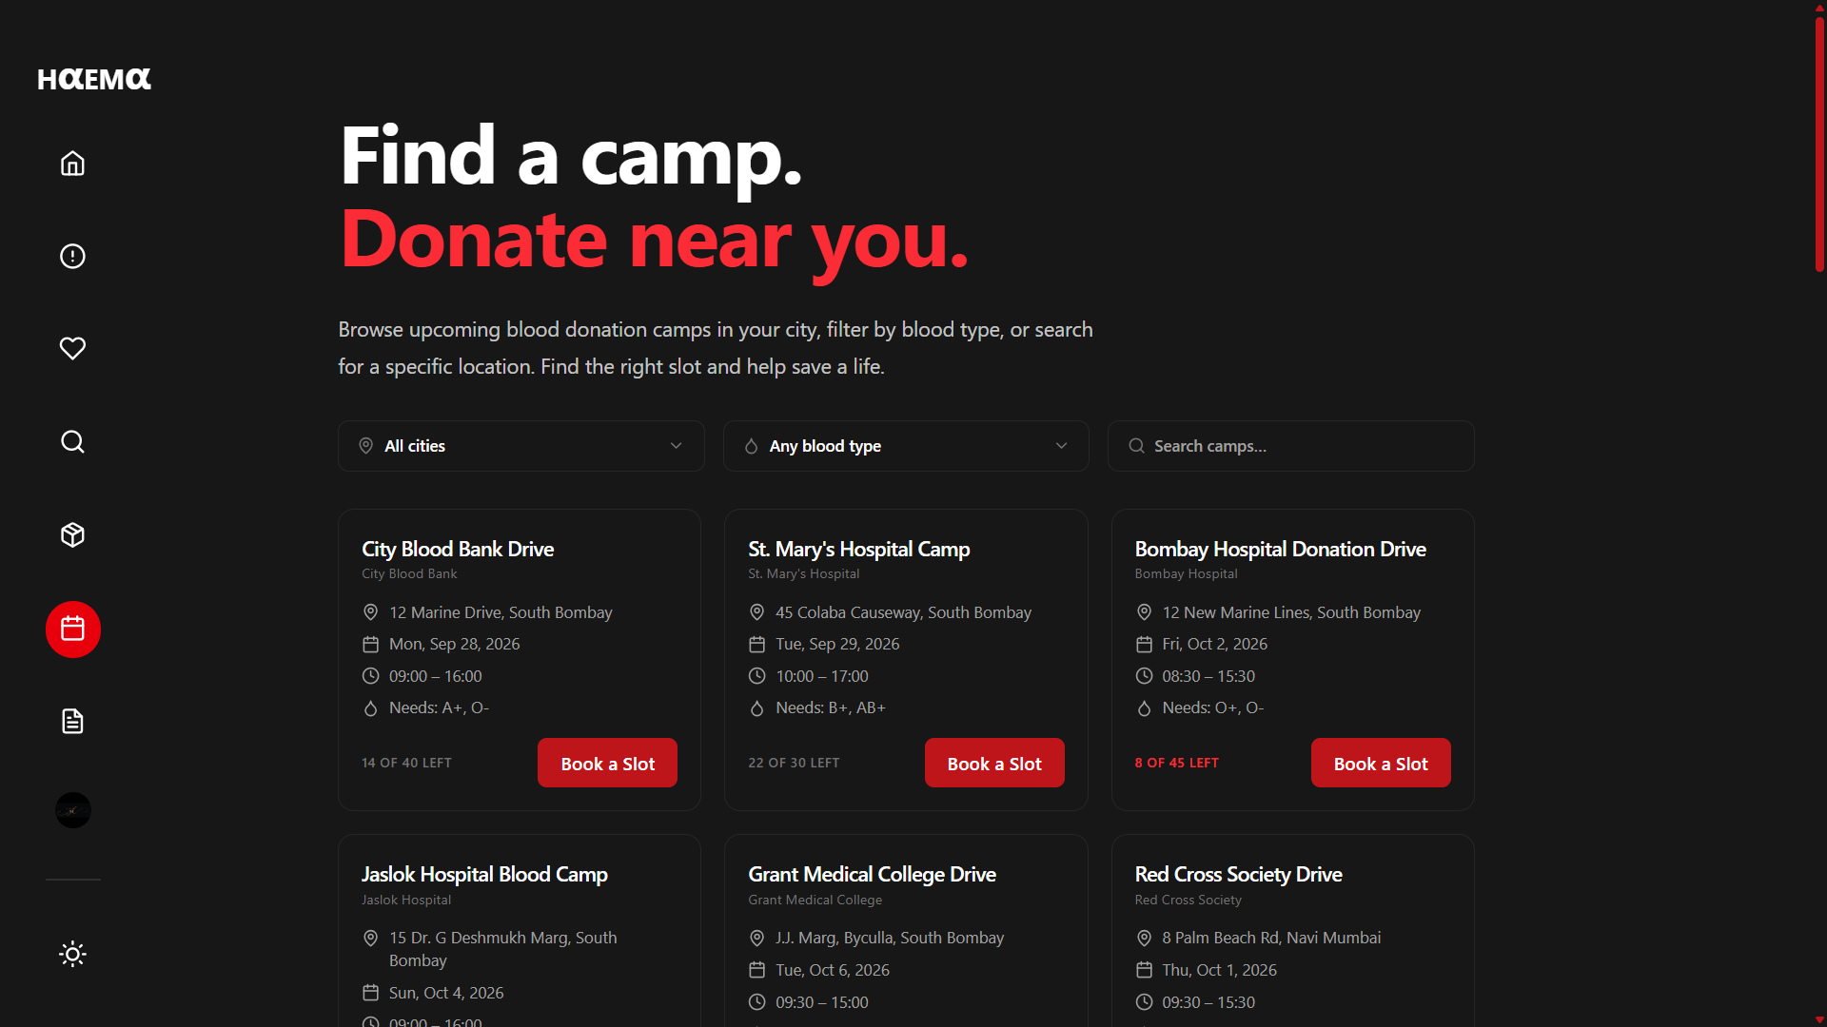

Fig.7

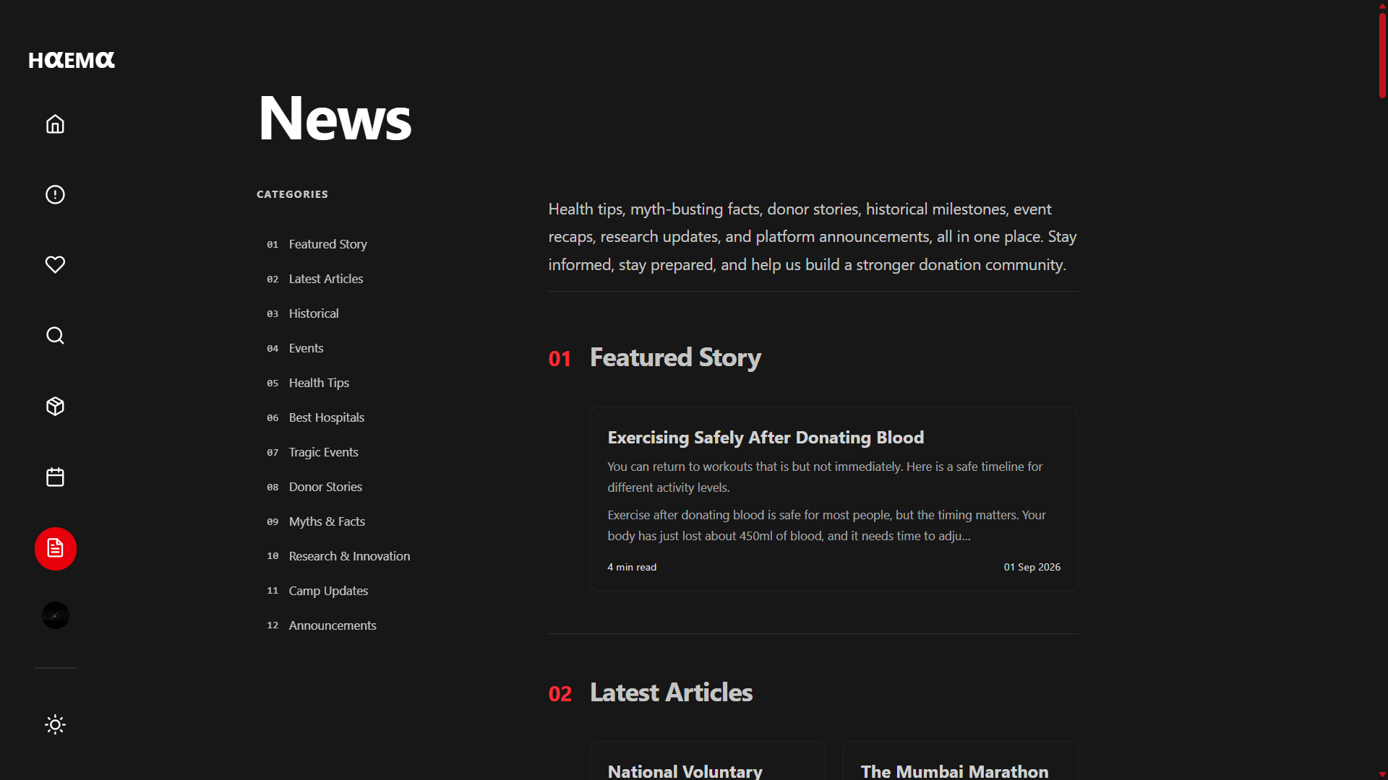

Fig.8

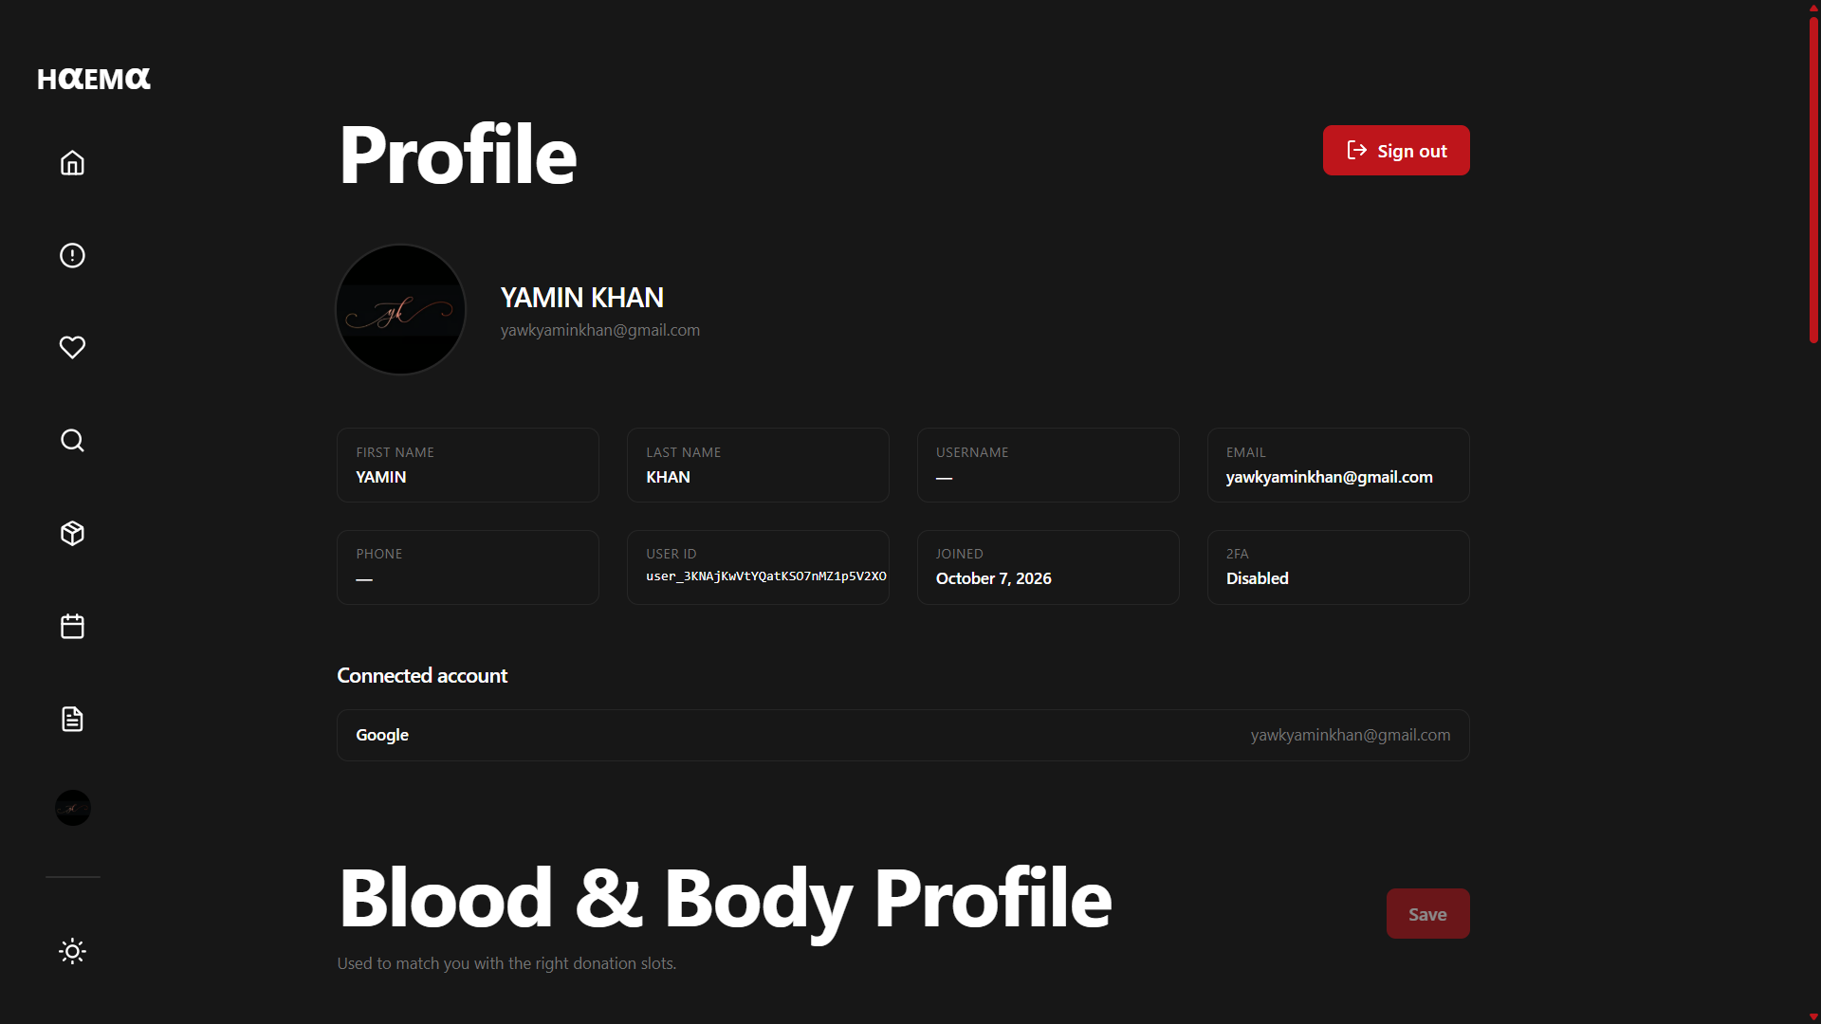

Fig.9

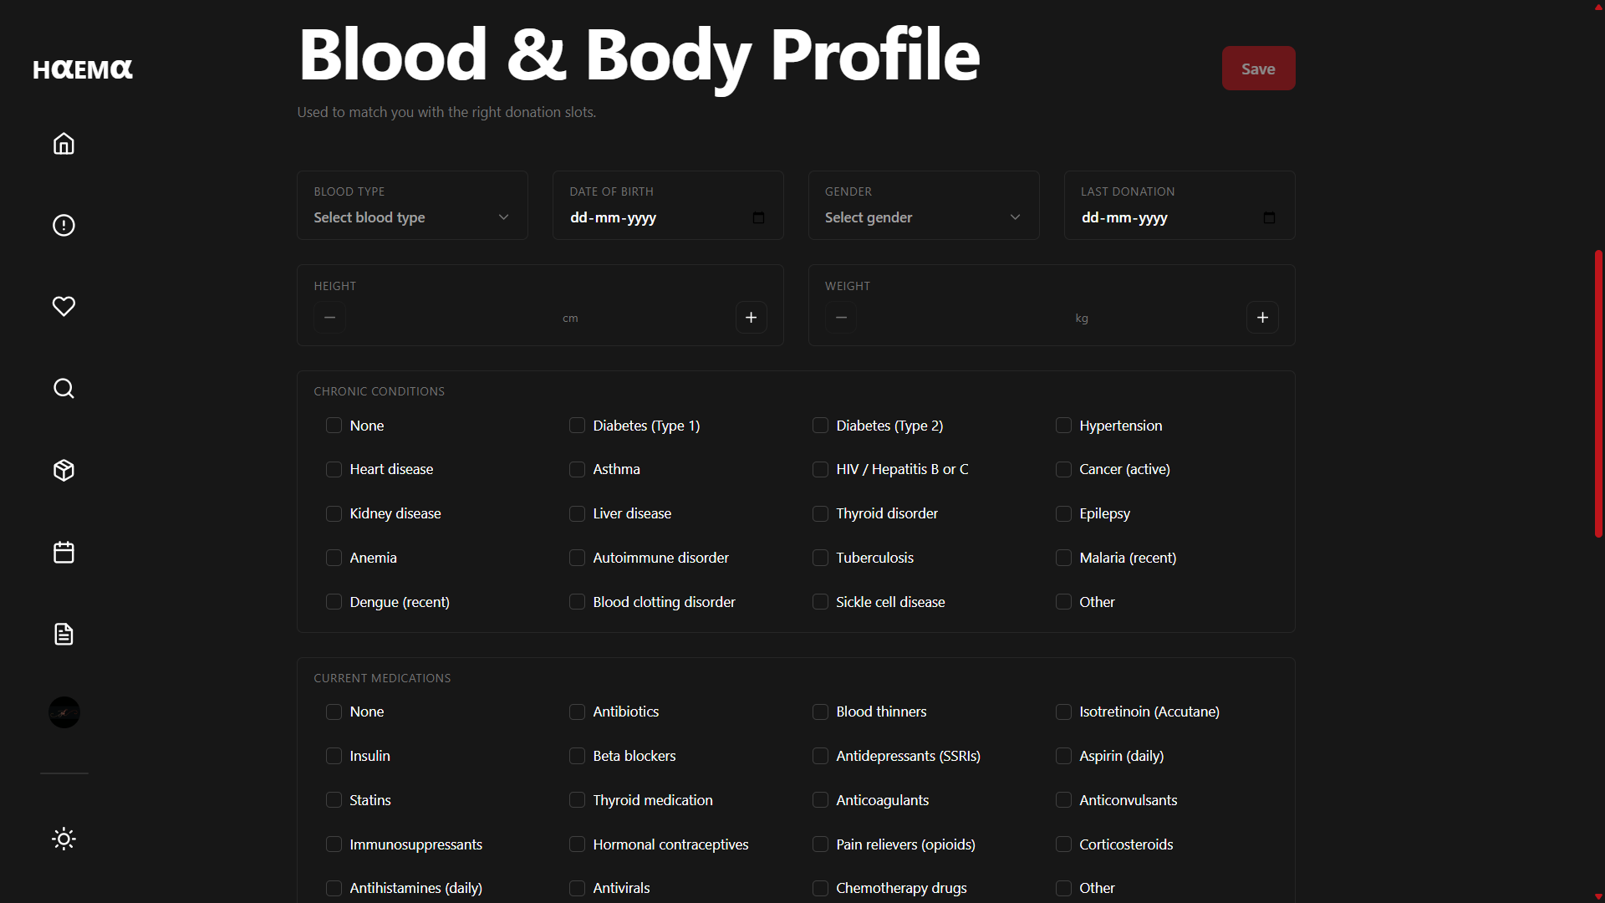

Fig.10

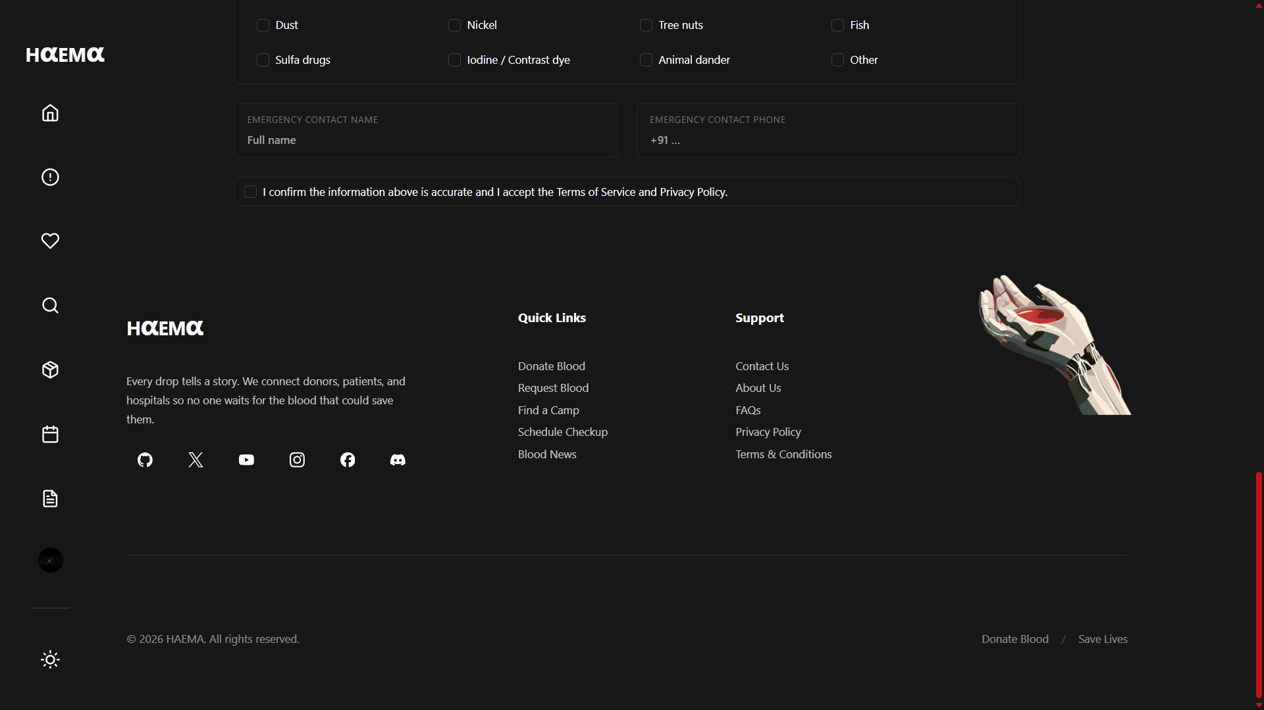

Fig.11

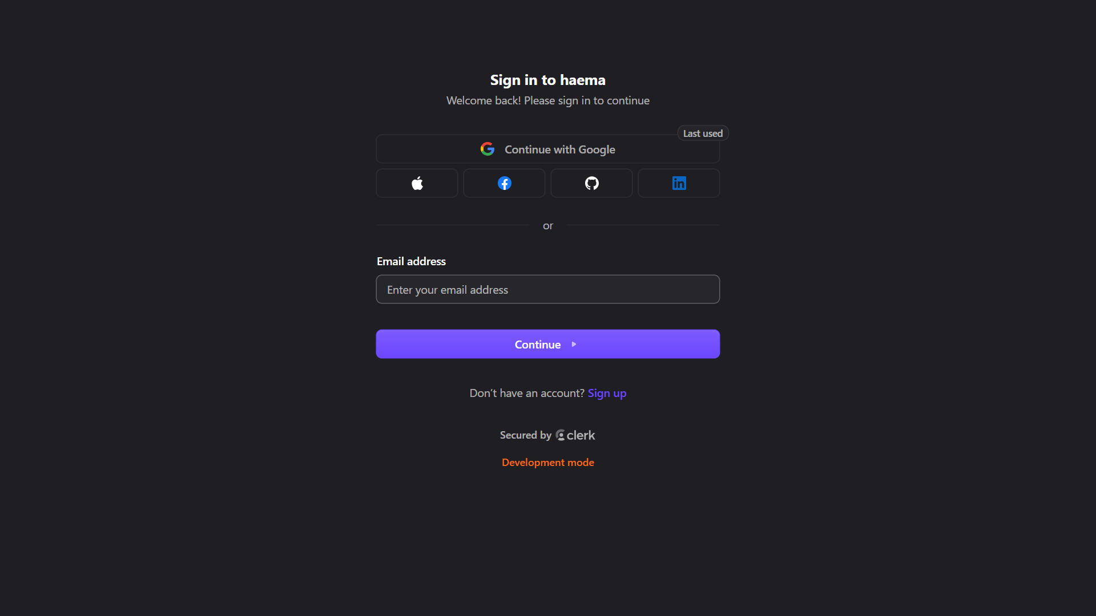

Fig.12

TIMELINE CHART

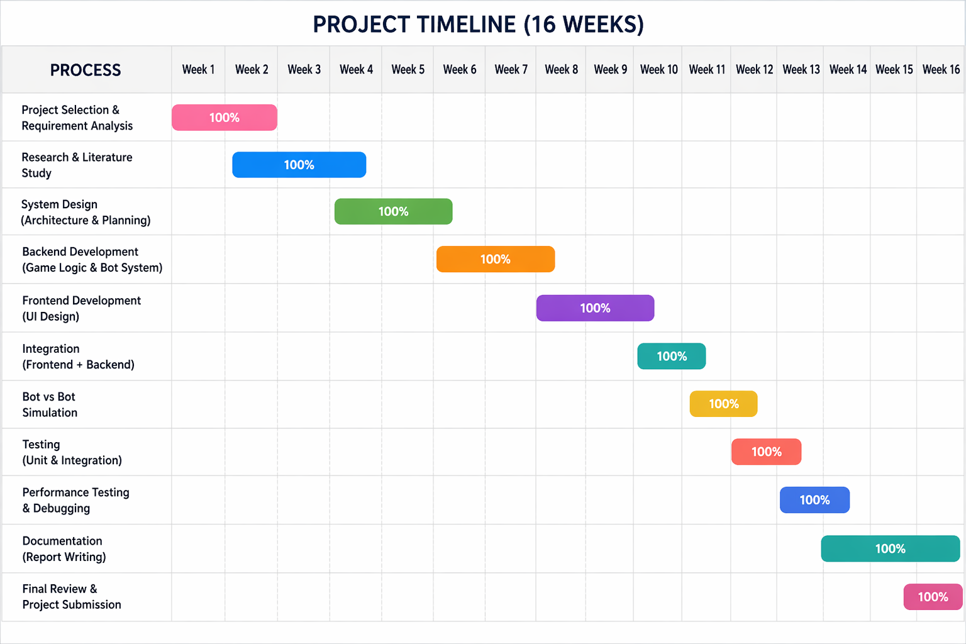
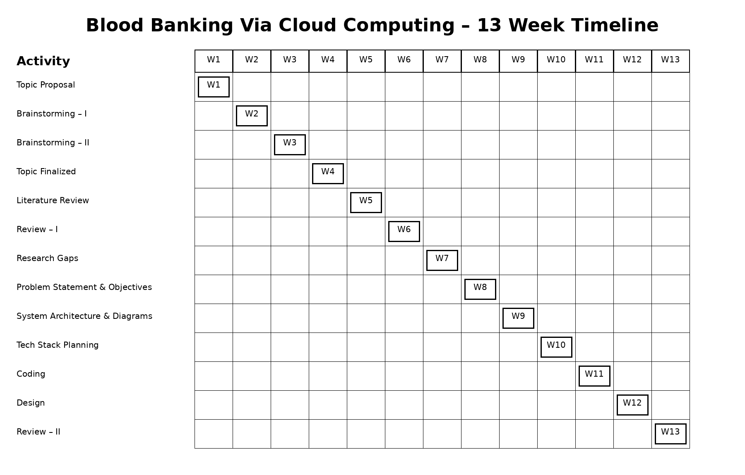

CONCLUSION

The Blood Banking Via Cloud Computing project proposes a centralized digital solution for managing blood-bank operations. By utilizing cloud computing, the system can provide improved accessibility, centralized data management, easier record maintenance, and better scalability compared with conventional approaches.
The proposed system covers important functions such as donor management, blood inventory management, blood searching, blood requests, authentication, and administration. The planned architecture separates the presentation, application, and database layers, making the system easier to maintain and extend.
In the future, the system can be enhanced with real-time notifications, emergency blood requests, location-based blood-bank searching, SMS/email alerts, analytics, mobile applications, and intelligent blood-demand prediction.

FUTURE SCOPE

The Blood Banking Via Cloud Computing system can be further enhanced with advanced technologies and additional features to make blood management faster, more reliable, and accessible.

1. Mobile Application
A dedicated Android/iOS application can be developed so that donors, hospitals, and administrators can access the system through smartphones.

2. Real-Time Blood Availability
The system can provide real-time blood-stock information by automatically updating inventory whenever blood is collected, issued, or transferred.

3. Emergency Blood Request
An emergency-request feature can allow hospitals or patients to mark a request as urgent and notify nearby eligible donors or blood banks.

4. Location-Based Blood Bank Search
GPS and location services can be integrated to help users find the nearest blood bank or available donor based on their location.

5. SMS and Email Notifications
The system can send automatic notifications for:
- Blood requests
- Donation reminders
- Request approval/rejection
- Low blood-stock alerts
- Emergency requirements

6. AI-Based Blood Demand Prediction
Machine Learning can be incorporated to analyze historical blood usage and predict future demand for different blood groups. This can help blood banks maintain adequate inventory.

7. Cloud-Based Analytics Dashboard
An analytics dashboard can display:
- Total donors
- Blood collected
- Blood issued
- Current inventory
- Most requested blood groups
- Monthly donation trends

8. Improved Security
Advanced security mechanisms such as multi-factor authentication, encryption, role-based access control, and audit logs can be implemented to protect sensitive healthcare information.

9. Integration with Hospitals
The platform can be integrated with hospitals and healthcare organizations so that authorized hospitals can directly submit and track blood requests.

10. IoT-Based Blood Storage Monitoring
IoT sensors can be used to monitor storage conditions such as temperature and humidity and generate alerts if conditions become unsafe.

11. Digital Donor History
A complete digital donation history can be maintained for each donor, helping authorized personnel track previous donations and donor eligibility.

12. Scalable Multi-Blood-Bank Network
In the future, multiple blood banks from different locations can be connected to the same cloud platform, creating a centralized blood availability network.

REFERENCES

Books
- Rajkumar Buyya, James Broberg, and Andrzej M. Goscinski, Cloud Computing: Principles and Paradigms, Wiley, 2011.
- Thomas Erl, Ricardo Puttini, and Zaigham Mahmood, Cloud Computing: Concepts, Technology & Architecture, Prentice Hall, 2013.
- Abraham Silberschatz, Henry F. Korth, and S. Sudarshan, Database System Concepts, McGraw-Hill Education.

Research / Technical References
- World Health Organization (WHO), Blood Safety and Availability, World Health Organization.
- World Health Organization (WHO), Guidance on Centralized and Hospital-Based Blood Management, WHO technical resources.
- National Blood Transfusion Council (NBTC), Government of India, National Blood Policy and Blood Transfusion Services, Ministry of Health and Family Welfare, Government of India.
- National Health Portal, Government of India, Blood Bank Services and Blood Donation Information, Ministry of Health and Family Welfare.

Web / Technology References
- Amazon Web Services, AWS Documentation – Cloud Computing and Cloud Services.
- MongoDB Documentation, MongoDB Database Documentation.
- Node.js Documentation, Node.js Official Documentation.
- React Documentation, React Official Documentation.
- GitHub Documentation, GitHub Developer and Repository Documentation.

